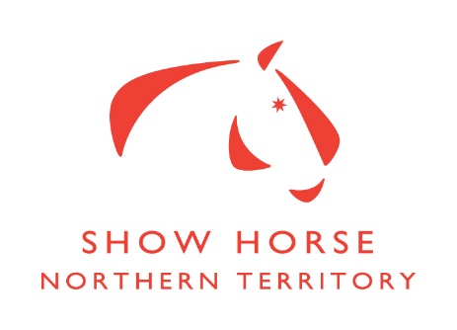

The Bendigo bank & ENT Horse and rider championship Class results
CLASS | JUDGE A | JUDGE B | FINAL PLACINGS
^{NEWCOMERS}
148
1st | 134 | 122 | 122
2nd | 122 | 107 | 134
3rd | 107 | 134 | 107
149
1st | 142 | 142 | 142
150
1st | 118 | 118 | 118
151
1st | 119 | 119 | 119
^{CHILDRENS}
117
1st | 116 | 116 | 116
2nd | 111 | 111 | 111
3rd | 110 | 110 | 110
118
1st | 109 | 128 | 128
2nd | 128 | 109 | 109
119
1st | 107 | 107 | 107
120
1st | 142 | 115 | 142
2nd | 115 | 142 | 115
3rd | 003 | 003 | 003
121
1st | 104 | 104 | 104
2nd | 136 | 136 | 136
122
1st | 108 | 108 | 108
2nd | 113 | 113 | 113
^{LEADING REIN}
123
1st | 114 | 114 | 114
124
1st | 132 | 132 | 132
2nd | 115 | 115 | 115
^{RIDER CLASSES}
125
1st | 004 | 004 | 004
2nd | 001 | 001 | 001
3rd | 003 | 003 | 003
126
1st | 006 | 006 | 006
2nd | 005 | 005 | 005
3rd | 008 | 008 | 008
127
1st | 011 | 011 | 011
2nd | 010 | 010 | 010
3rd | 012 | 012 | 012
128
1st | 019 | 019 | 019
2nd | 016 | 016 | 016
3rd | 017 | 017 | 017
^{HUNTER CLASSES}
129
1st | 115 | 115 | 115
2nd | 140 | 140 | 140
131
1st | 131 | 131 | 131
2nd | 142 | 142 | 142
3rd | 139 | 139 | 139
132
1st | 121 | 121 | 121
2nd | 136 | 136 | 136
133
1st | 104 | 104 | 104
134
1st | 108 | 108 | 108
2nd | 105 | 105 | 105
3rd | 133 | 133 | 133
135
1st | 106 | 106 | 106
2nd | 148 | 148 | 148
3rd | 130 | 130 | 130
^{SHOW HACK}
136
1st | 001 (114) | 001(114) | 001 (114)
137
1st | 144 | 144 | 144
138
1st | 127 | 127 | 127
2nd | 116 | 116 | 116
3rd | 111 | 111 | 111
139
1st | 124 | 124 | 124
140
1st | 109 | 109 | 109
2nd | 101 | 101 | 101
141
1st | 117 | 117 | 117
2nd | 122 | 122 | 122
3rd | 107 | 107 | 107

TRACK TO HACK
^{FASHION ON FIELD}
1st | 106
2nd | 120
3rd | 122
^{LED}
1st | 120
2nd | 122
3rd | 106
^{RIDDEN}
1st | 106
2nd | 120
3rd | 122
^{OVERALL PLACINGS}
1st | 106
2nd | 120
3rd | 122

^{LEDS}
101 |  | 102
1st | 127 | 1st | 118
2nd | 134 | 2nd | 139
3rd |  | 3rd | 108
103 |  | 104
1st | 143 | 1st | 132
2nd | 122 | 2nd | 119
3rd | 101 | 3rd | 103
105 |  | 106
1st | 127 | 1st | 133
2nd | 143 | 2nd | 134
3rd | 101 | 3rd
107 |  | 108
1st | 118 | 1st | 132
2nd | 119 | 2nd
3rd | 103 | 3rd
^{RIDDEN BREEDS}
109 |  | 110
1st | 109 | 1st | 104
2nd | 111 | 2nd | 117
3rd | 127 | 3rd | 133
111 |  | 112
1st | 103 | 1st | 110
2nd | 119 | 2nd | 137
^{NOVICE CLASSES}
113 |  | 114
1st | 124 | 1st | 122
2nd | 101 | 2nd | 107
3rd |  | 3rd | 134
115 |  | 116
1st | 139 | 1st | 130
2nd |  | 2nd | 105
3rd |  | 3rd | 103

AUSTRALIAN STOCK HORSE HIGH POINT
HORSE | TOTAL POINTS
103 | 9
118 | 20
119 | 18
HIGHPOINT WINNER | 118

